# 

NAME : GEETHASRI

GMAIL : [tthirunaharigeethasri@gmail.com](mailto:tthirunaharigeethasri@gmail.com)

Create three instance

Attach one EFS to two instance

Attach one EBS to two instance

Create three instance

First instance

* Go to aws search bar and search EC2 then click on it
* 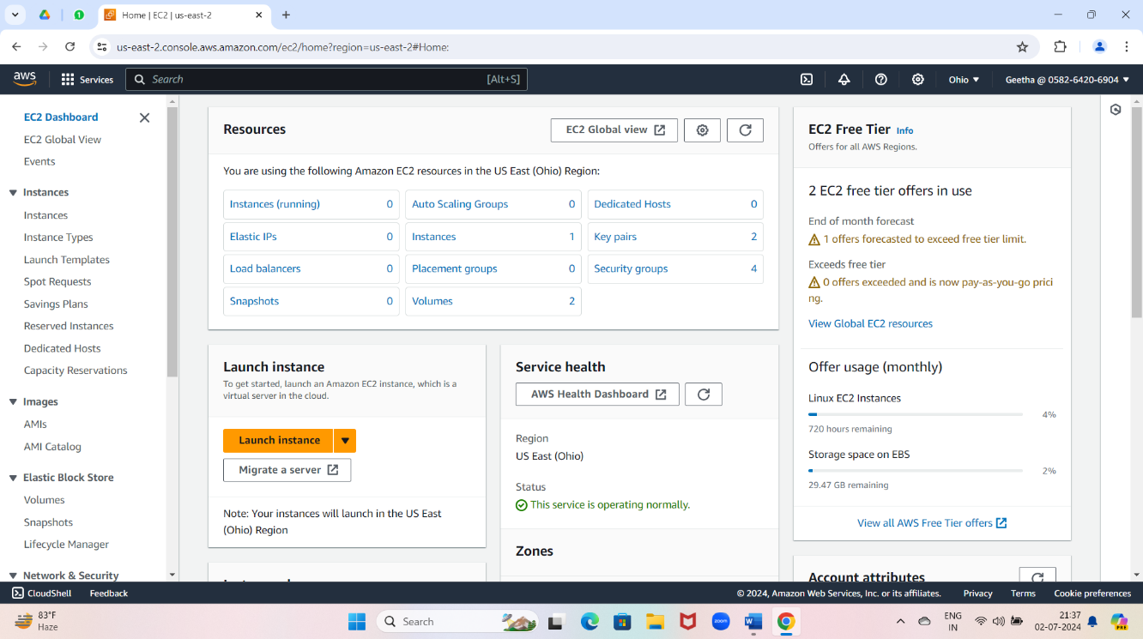Now we have to create first instance
* Now click on instance (running)
* 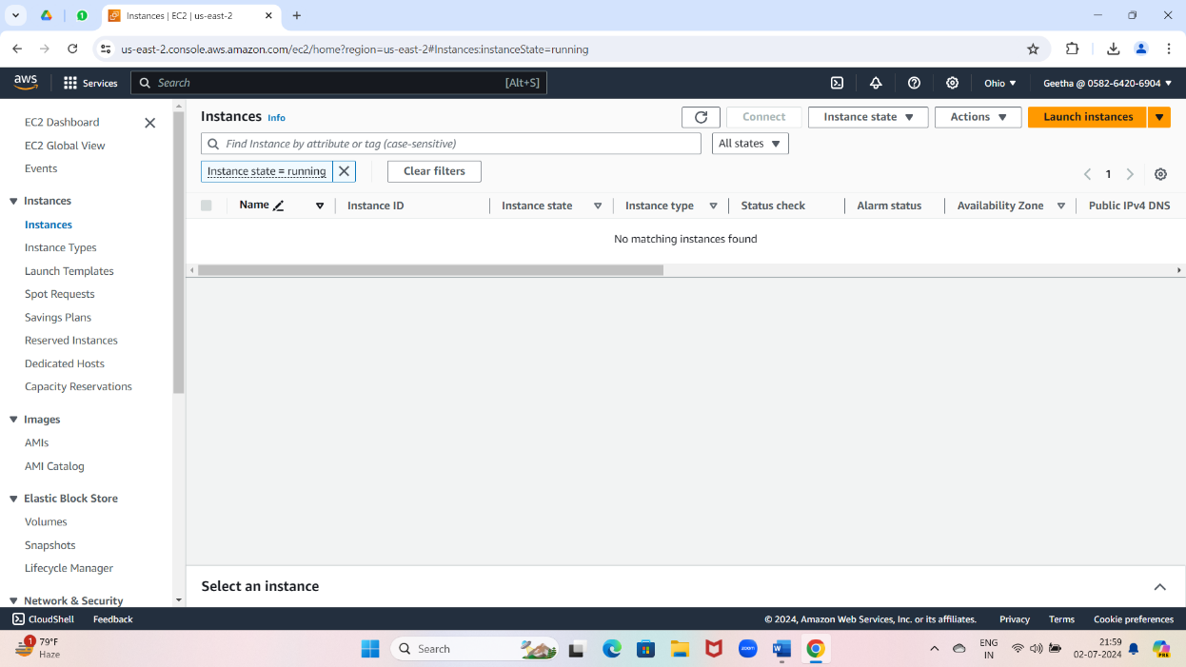Click on launch instances
* Give the server name

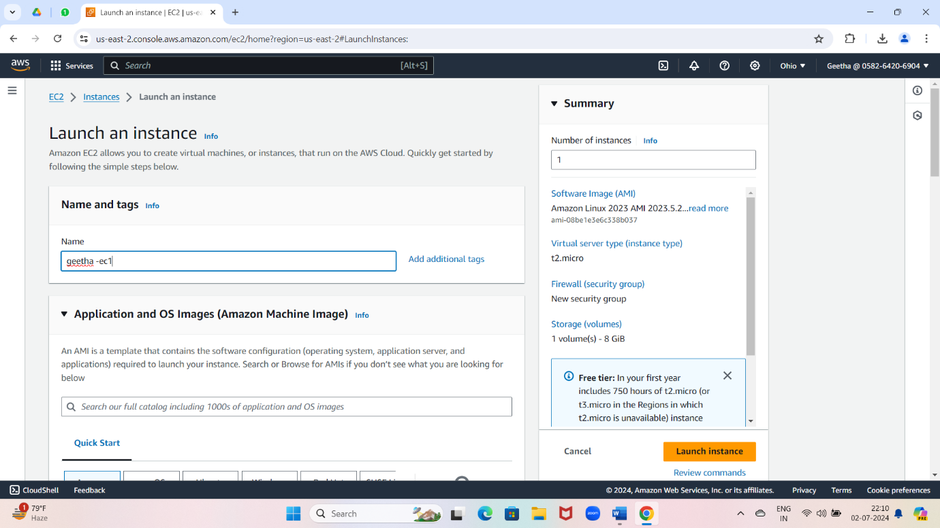

* 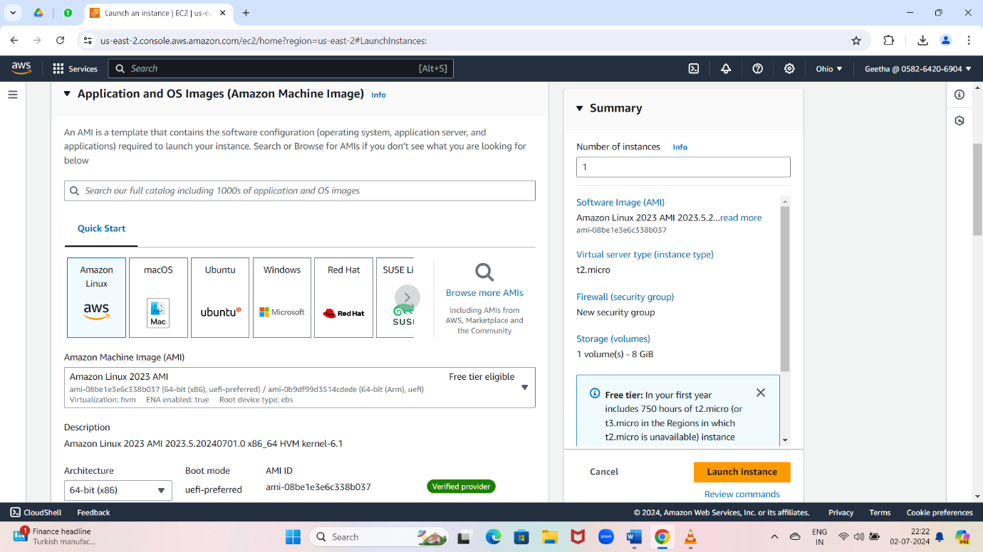Select OS images
* Create a key pair

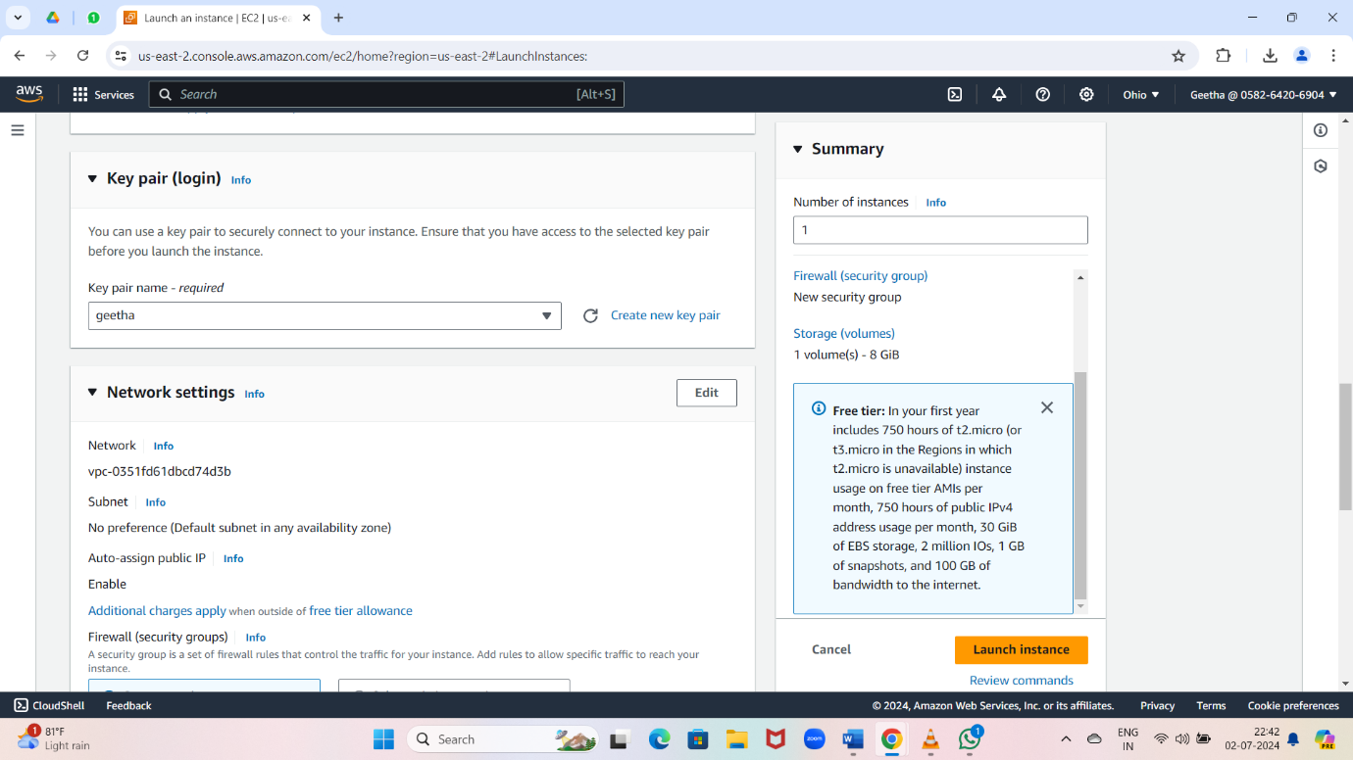

* 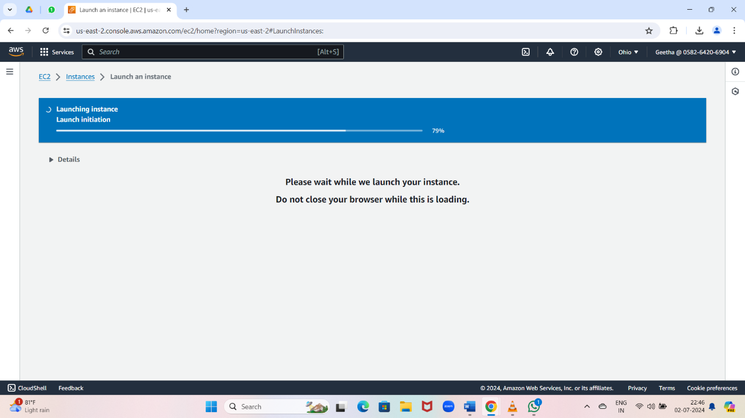Click on launch instances
* Click on instances

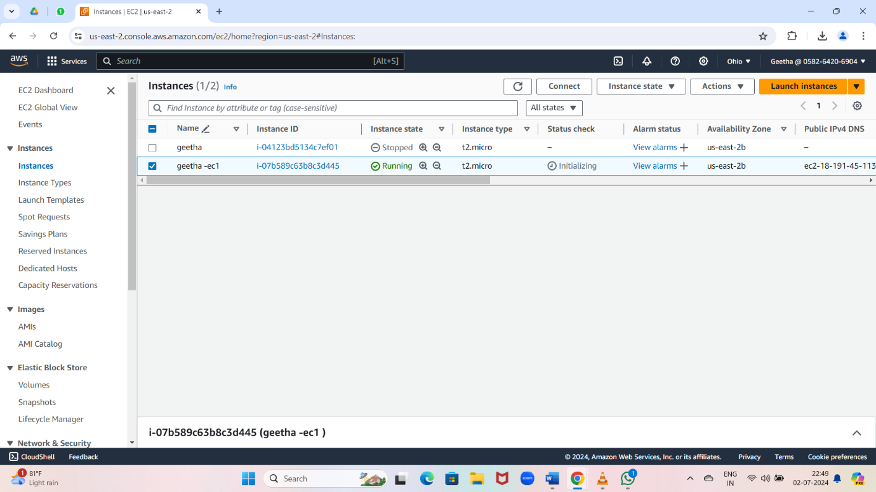

* Repeat same process for two instance

1.ATTACH ONE EBS TO ONE INSTANCE

* Create a volume

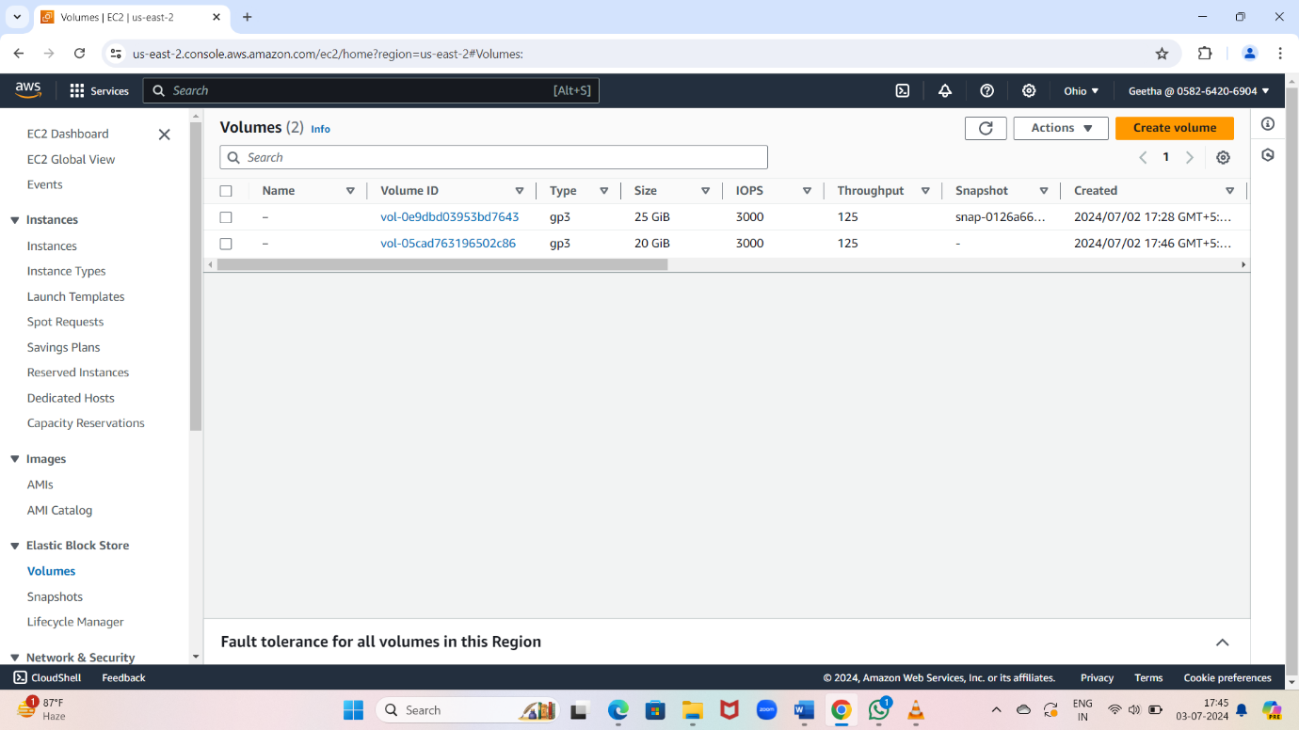

* Connect instance

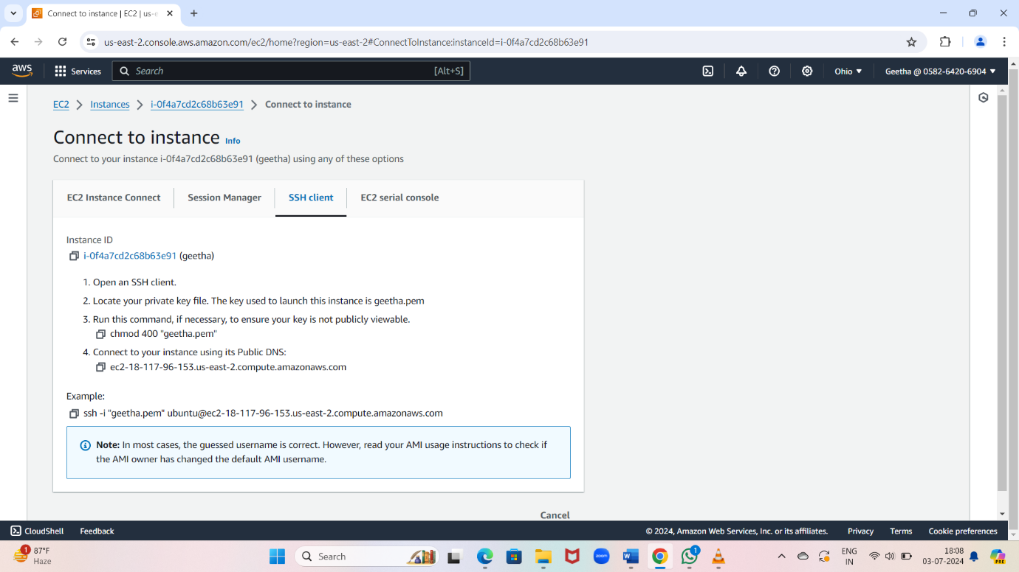

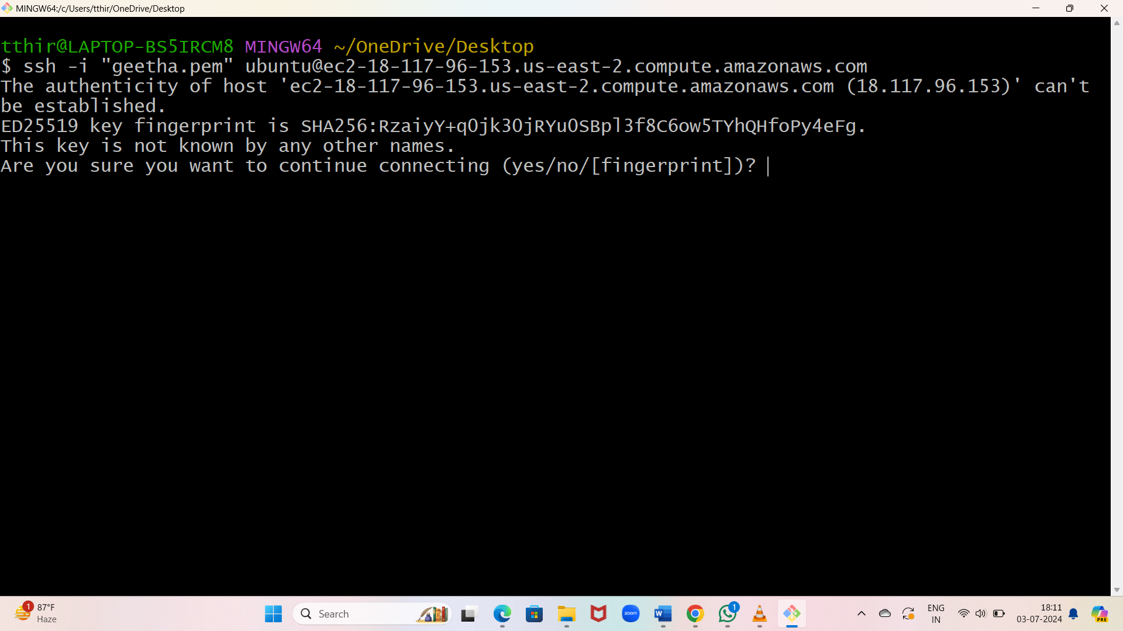

* + Check storage

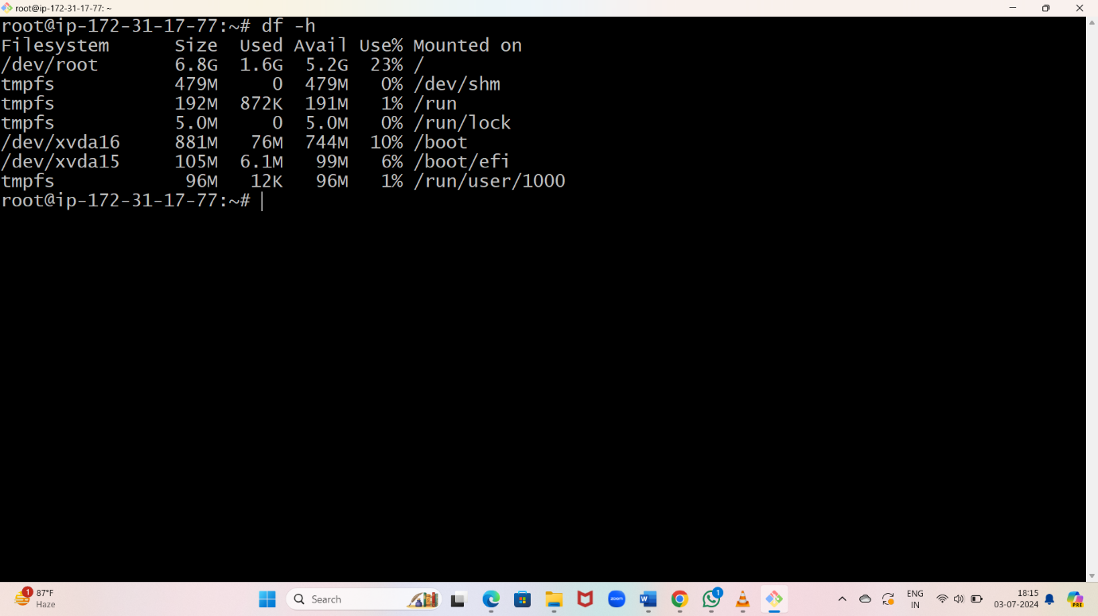

* To increase size

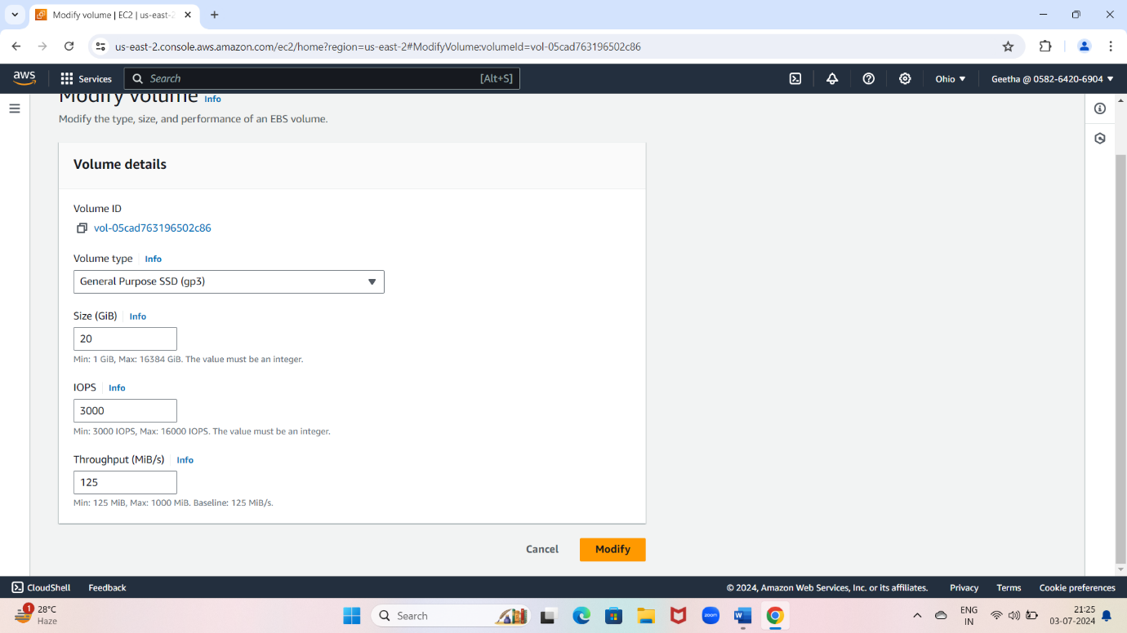

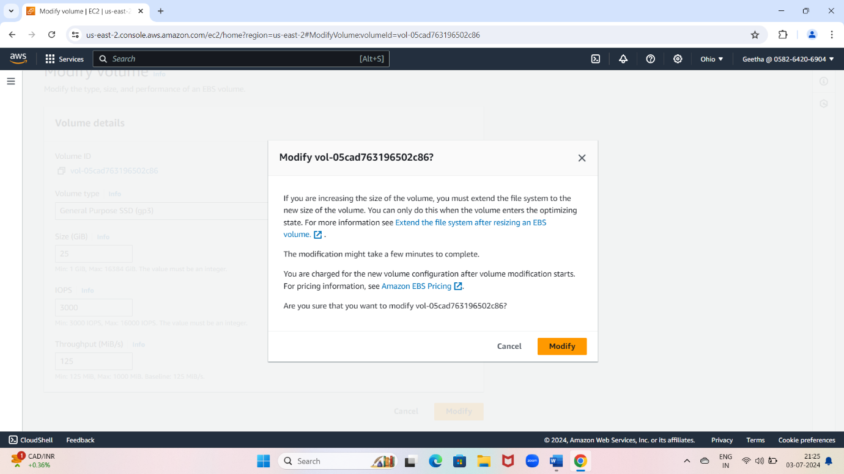

* + To reflect the size reboot the instance

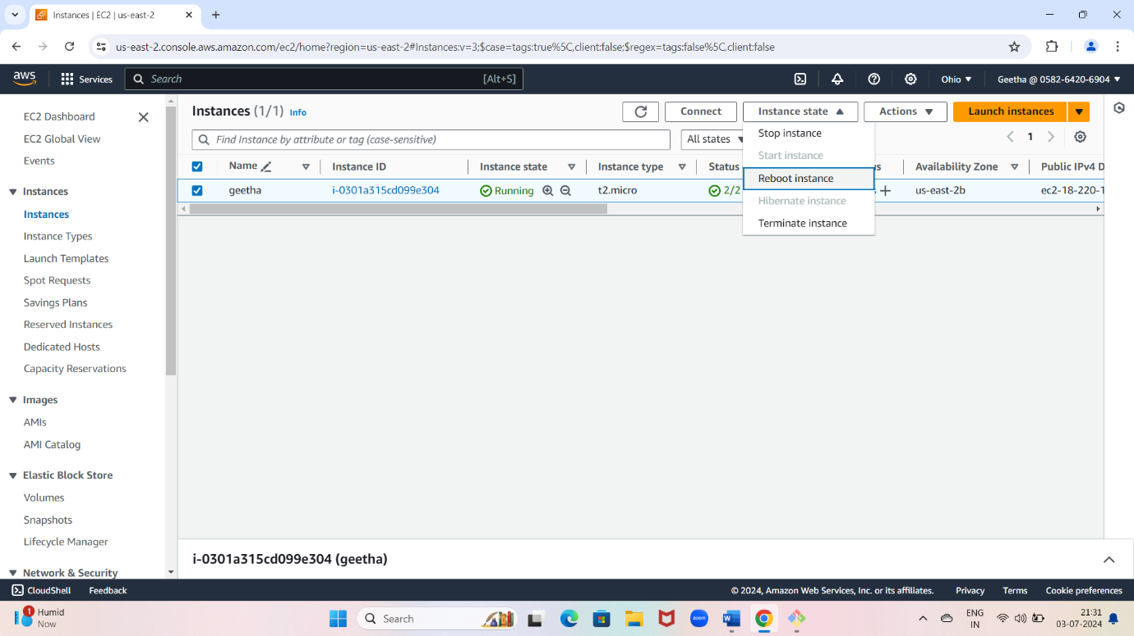

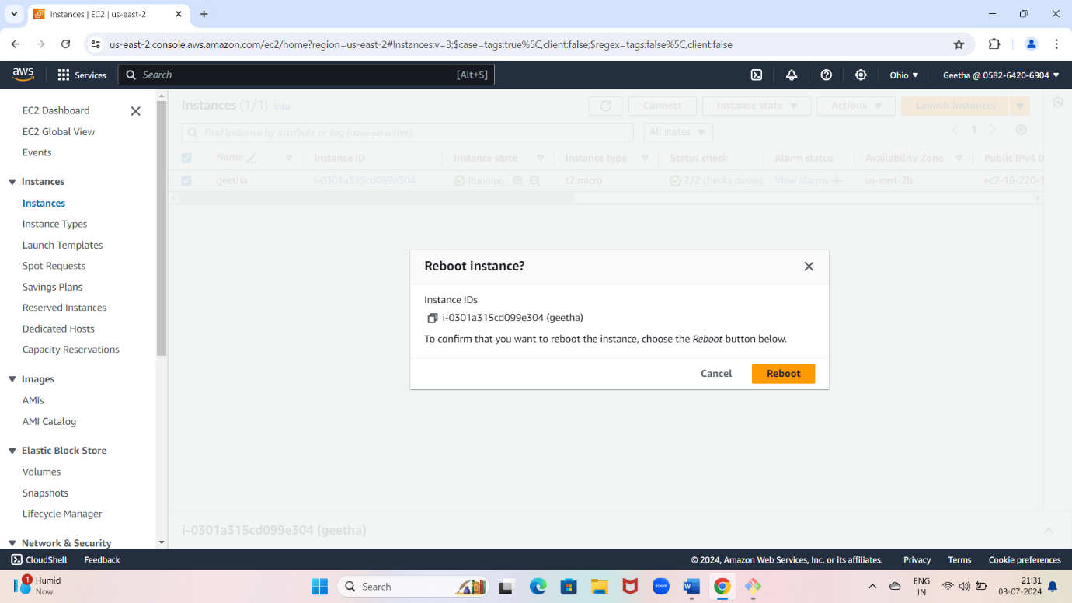

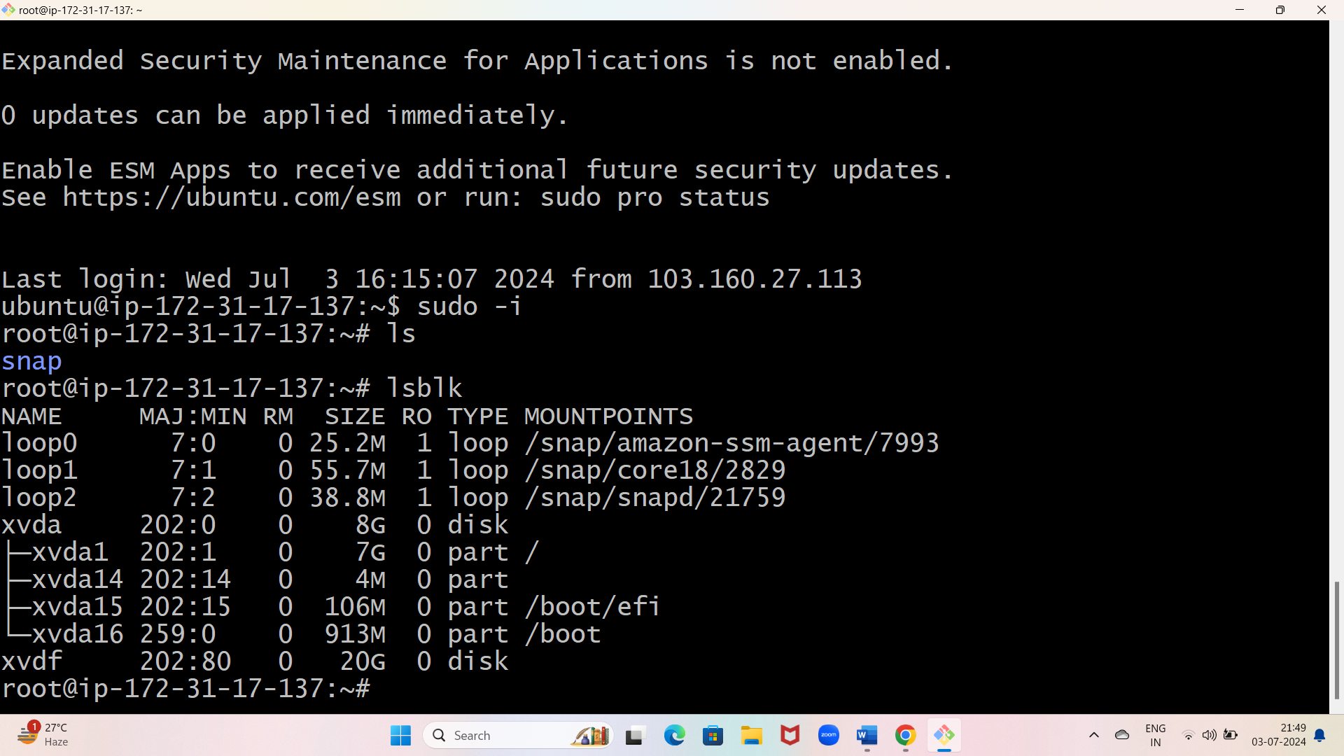

* The size is increased
* List all block device by using “ lsblk ” command
* Check file system by using “file -s /dev /xvdf” command
* Create directory by using “mkdir -p app/user” command
* Mount the directory by using “mount/dev/xvdf app/user” command
* To check disk free by using “df -h “ command

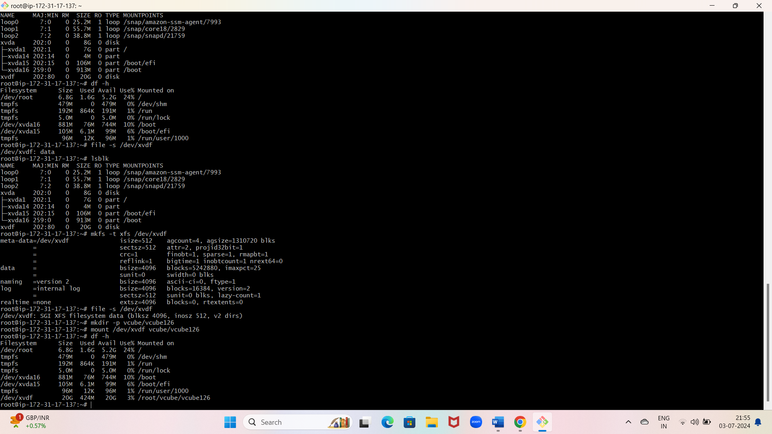

1. ATTACH ONE EFS TO TWO INSTANCE
   * Create security group

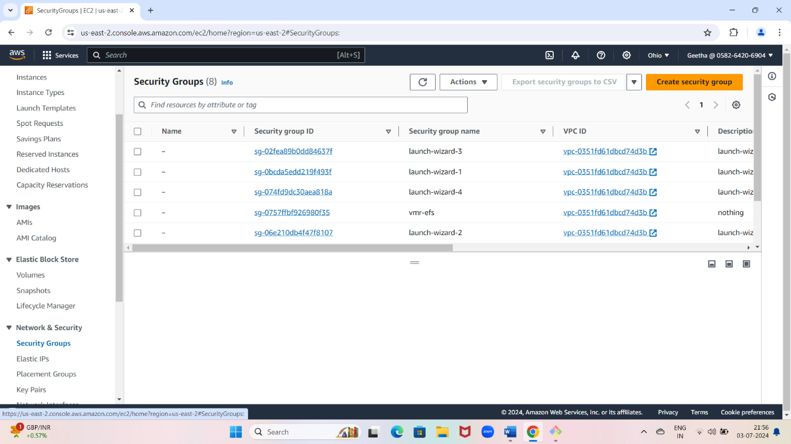

* Give security group name

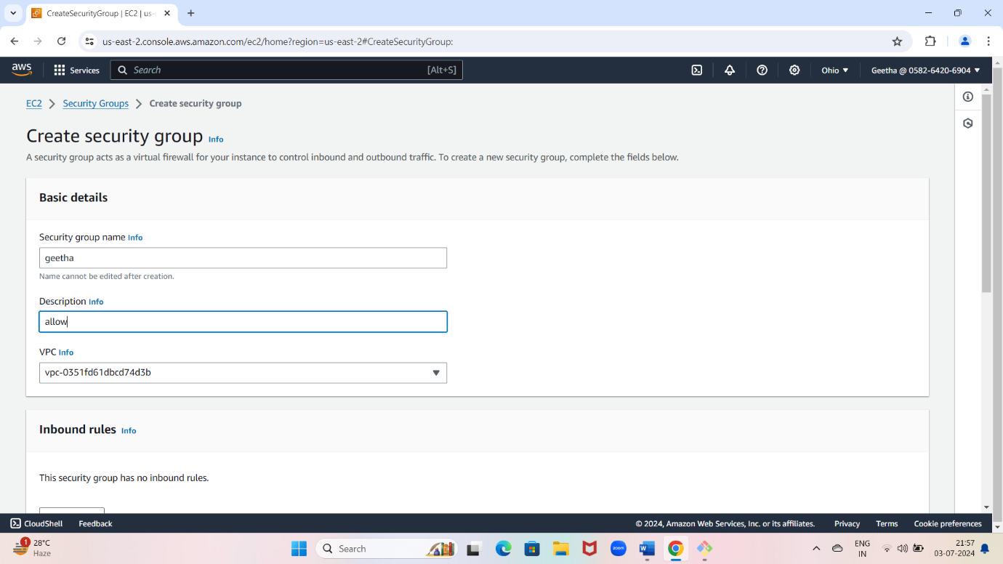

* + Security group will create

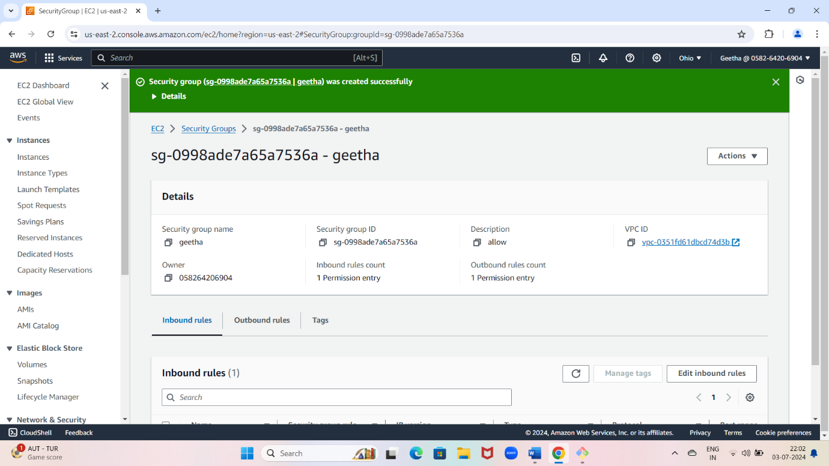

* Go to aws bar search EFS and click on it

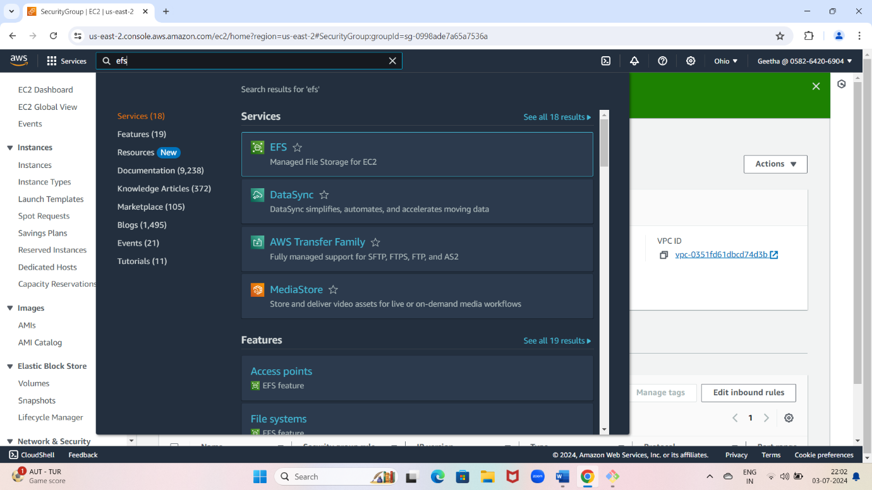

* Create file system

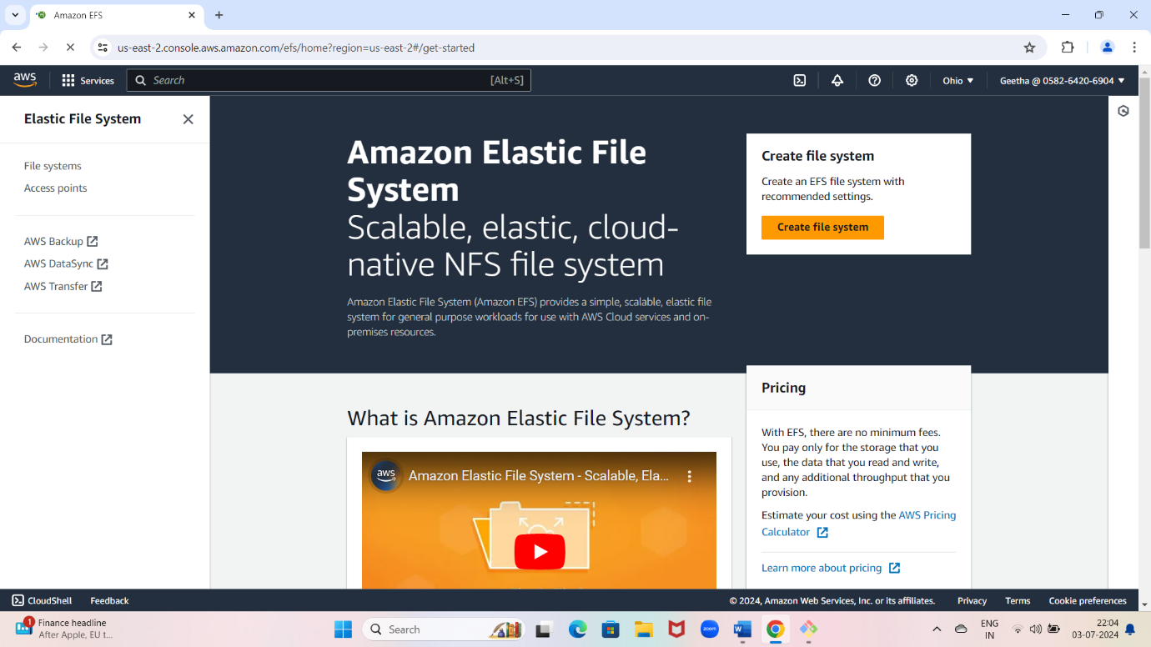

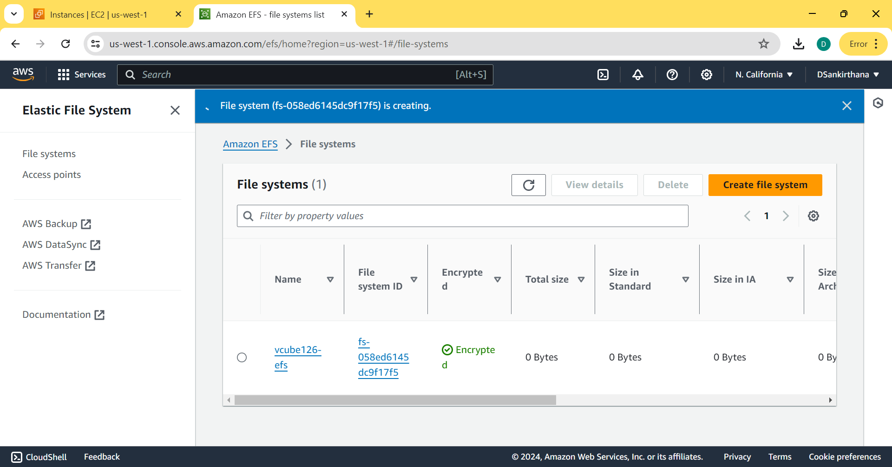

* Lunch two instance and connect instance

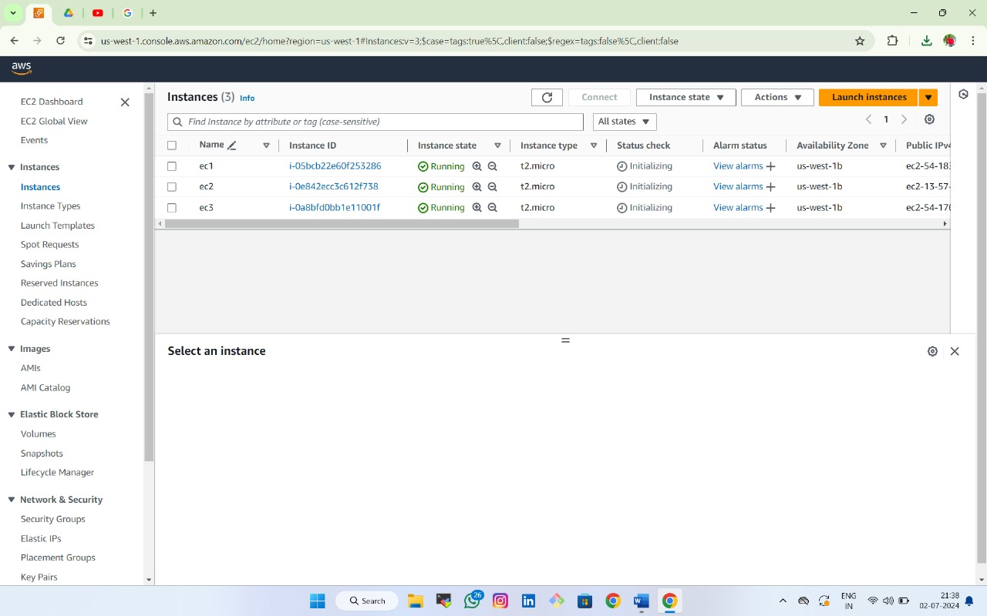

* EFS 1
* Create a file system in EFS 1 and store some data in file system

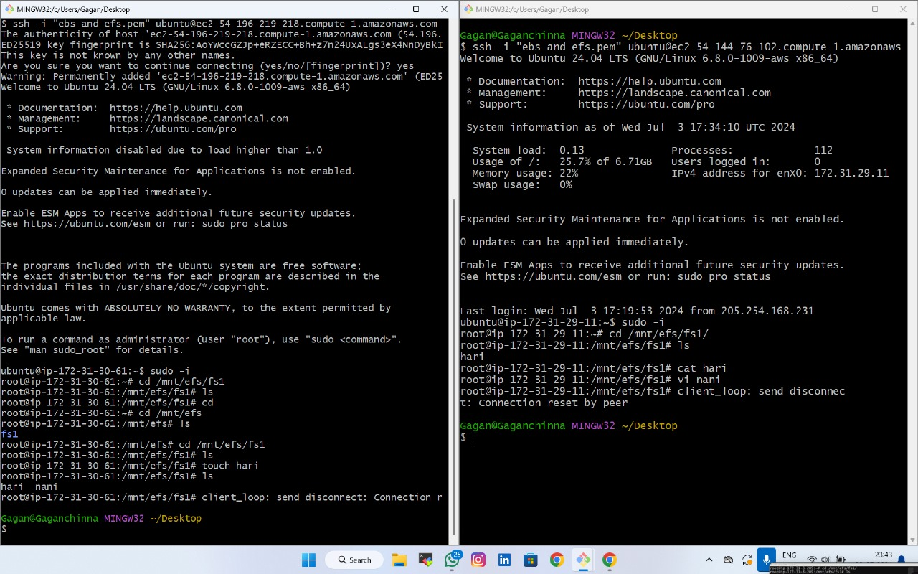

* EFS 2
* Create a file system in EFS 2 and store some data in file system



* Both severs shares same file and data these
* Type of data sharing is known as EFS